Game Design Document

Fill up the following document

1. Write the title of your project.

Escape The Zombie

1. What is the goal of the game?

Get The Highest Score Possible While Escaping The Zombie!

1. Write a brief story of your game.

A Girl Is Trying To Escape From Zombies During An Zombie Infection She Is The Only One Left!

1. Which are the playing characters of this game?

* Playing characters are the ones who respond to the user based on the input from the user.
* Cars, monkeys, dinos, wizards, etc., are the playing characters in the game.

|  |  |  |
| --- | --- | --- |
| Number | Character Name | What can this character do? |
| 1 | Girl | Run An Jump |
| 2 |  |  |
| 3 |  |  |
| 4 |  |  |
| 5 |  |  |
| 6 |  |  |
| 7 |  |  |
| 8 |  |  |

1. Which are the Non-Playing Characters of this game?

* Non-Playing characters are the ones that don't have an action or behavior when the user interacts with the game.
* Hurdles, stones, bananas, coins, etc., are non-playing characters in the game.

|  |  |  |
| --- | --- | --- |
| Number | Character Name | What can this character do? |
| 1 | Zombie | Infect The Player And Run Behind The Player |
| 2 |  |  |
| 3 |  |  |
| 4 |  |  |
| 5 |  |  |
| 6 |  |  |
| 7 |  |  |
| 8 |  |  |

Draw your imagination of this game. What does this game look like?

* Draw the game either on your computer or on paper.
* Add images of the game scenes to show each of the playing and non-playing characters at least once.

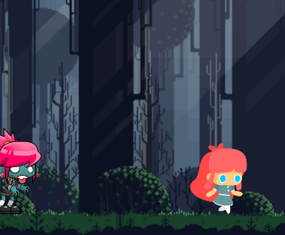

How do you plan to make your game engaging?

The Scoring Of The Game Makes People Want Play it More Because The Longer They Play The Higher Score They Get